**Reference 1 (Review of terahertz and subterahertz)**

This paper focuses on the terahertz (THZ) and sub terahertz (SUB-THZ) waves of the electromagnetic spectrum and how they will fit into the future of wireless communication. The author not only considers THZ in general, but how it differs in free space versus guides media and outdoor versus indoor communications [2]. There has not yet been experiments testing how THZ behaves in unfavorable conditions. These conditions include fog, rain, and other particles that can cause interference with other types of waves [9]. However, even though experiments have not been conducted, experts predict that the small particles that can be found in the atmosphere will not cause any issues with THZ and SUB-THZ communications. THZ waves require line-of-sight communication so, indoor uses of THZ and SUB-THZ waves are not likely to be widely used. However outdoor use of these waves seems to be coming up in the future [7].

The author begins to discuss how THZ waves could be used for different types of secure communication. One major example given of this case is when the Department of Defense (DOD) used secure wireless THZ communications between mobile computers and the sender. These situations were used for short range line-of-sight communication. The communications were kept close range because the DOD wanted to keep the communications secure [9].

One problem proposed by the author was that current antennas used by the current wireless standards would not be able to detect THZ and SUB-THZ frequencies. This means that if THZ was to become the normal frequency for communication, then these antennas would need to be replaced or new antennas would need to be placed near existing ones. Modulation would also be required to effectively use THZ and SUB-THZ communication [15].

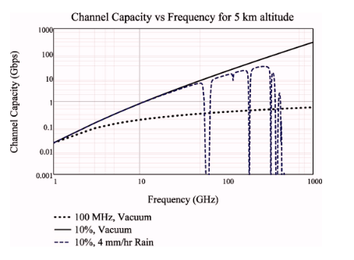

Figure 4 on page 6.

**Reference 2 (Sub-terahertz transmission experiment for future**

**wireless high speed data communication)**

This paper was written to describe the authors concerns over bandwidth capacity of the microwaves currently being used for commination. The author proposes that THZ waves could be used in the future to increase bandwidth capacity. University of Electronic Science and Technology of China conducted an experiment to determine if THZ will be a valid solution to complication described above [1]. The experiment measured transmission system performance and the noise performance is analyzed in terms of output signal to noise ratio. The experiment concluded that THZ would be a valid way to increase bandwidth when compared to current methods. A data rate of 10 Gbit/s was successfully transmitted using the transceiver in the experiment. This mean that is thought that THZ is a valuable technology that can be used in the future for increasing bandwidth over wireless communications.

**Reference 3 Summary (Indoor Terahertz)**

Terahertz (THz) communication is slowly gaining traction that could potentially lead to increased data rates in the Terabits-per-second (Tbps) range. The study conducted tested THz communication within an indoor system to evaluate the performance and reliability of a THz communication system using multiple antennas with subarrays. The conclusions of this experiment conducted resulted in the THz system using Tbps data speeds to outperform conventional communication systems using only one array of antennas [9]. Regarding the subarray size, the larger subarray size will result in degradation of the wireless communication and will eventually reach a limit where it is no longer efficient [9]. 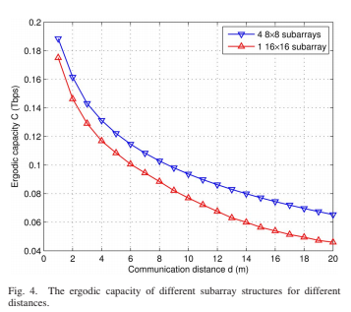

**Reference 4 Summary (Ultrafast Terahertz Wireless Comm)**

Terahertz communication (THz) in the frequency band from 100 GHz to 3 THz is being researched and companies are creating experiment technologies such as antennas to test the efficiency of these frequencies. NTT has created a transmitter and receiver chip that has been tested for data transmission speeds of 24 Gb/s at 300 GHz, transmitting large amounts of data through a wireless medium that could be used for commercial events such as conferences [2]. Depending on the implementation, transmission loss is common in THz communication using metal transmission lines that shorten the length data can travel. Development of THz communication is being aimed toward speeds of 100 Gb/s by increasing the carrier frequency of wireless links and using multi-level modulation [3]. Standardization for THz technology is currently being worked on and the IEEE802.15.3d standard includes the use of 100-Gbit radio transmission technology [4].

**Reference 5 Summary (Terahertz beyond 5G)**

The introduction of the Terahertz frequency band has bridged the gap between radio and optical frequency ranges with a promising future to increase the data ranges. Silicon architecture has been created to keep large wavelengths in a microchip, which allows the frequency which makes it easier to deal with multi-carrier THz channel switches due to the carrier [1]. The author has discussed several opportunities to use THz band for wireless use such as the Hybrid Terahertz-Optical Wireless Communication Links, which will allow a one-way or a two-way connection through any weather [4]. In conclusion, THz frequency is expected to fill in for the ever-increasing demand of network traffic caused by clients in wireless communication.

**Reference 6 Summary (World for T-rays)**

Scientists have been looking into terahertz after its discovery and have figured out that it is a small part of the light spectrum named the THz gap. There have been several ways to use t-rays for use such as finding hidden messages through layers of paintings or studying the chemical structure of a particular object. T-rays are also shown to be powerful enough to find new galaxies unknown to other telescopes or find tiny non-metallic pieces in other objects such as food [8]. Although t-rays are non-ionizing and do not damage the human body, it is hard to examine the body using t-rays since water absorbs t-rays easily.

